Name: ……………………………………………….. ( ) Class: ……… Date: ………………….

|  |  |  |
| --- | --- | --- |
| **3.2** | **Algorithm Design** | **Dry Runs, Trace Tables and Logic Errors** |

1. A dry run of an algorithm produced the trace table below. However, not all the variables are shown. Determine the purpose of the algorithm.

|  |  |  |  |
| --- | --- | --- | --- |
| **input** | **count** | **prime** | **Output** |
|  | 0 |  |  |
|  |  | 0 |  |
| 11 |  |  |  |
|  | 1 |  |  |
|  |  | 1 |  |
| 12 |  |  |  |
|  | 2 |  |  |
| 13 |  |  |  |
|  | 3 |  |  |
|  |  | 2 |  |
| 14 |  |  |  |
|  | 4 |  |  |
| 15 |  |  |  |
|  | 5 |  |  |
| 16 |  |  |  |
|  | 6 |  |  |
| 17 |  |  |  |
|  | 7 |  |  |
|  |  | 3 |  |
| 18 |  |  |  |
|  | 8 |  |  |
| 19 |  |  |  |
|  | 9 |  |  |
|  |  | 4 |  |
| 20 |  |  |  |
|  | 10 |  |  |
|  |  |  | 4 |

……………………………………………………………………………………………………………………………………………....

……………………………………………………………………………………………………………………………………………....

……………………………………………………………………………………………………………………………………………....

2. An algorithm is required to find the average of 5 numbers stored in a list. The input is provided in a list called “Number” and the output is provided through a variable named “Average”. Study the following pseudo-code.

|  |
| --- |
| 1 Total = 500  2 FOR Count = 0 to 5  3 Total = Total – Number[Count]  4 Count = Count + 1  5 NEXT Count  6 Total = Average / 5  7 OUTPUT Average |

There are **five** errors in this pseudo-code. Locate the errors and either provide the corrected pseudo-code or explain how the code can be corrected.

Error 1 …………………………………………………………………………………………………………………………………….

Correction ………………………………………………………………………………………………………………………………

……………………………………………………………………………………………………………………………………………….

Error 2 …………………………………………………………………………………………………………………………………….

Correction ………………………………………………………………………………………………………………………………

……………………………………………………………………………………………………………………………………………….

Error 3 …………………………………………………………………………………………………………………………………….

Correction ………………………………………………………………………………………………………………………………

……………………………………………………………………………………………………………………………………………….

Error 4 …………………………………………………………………………………………………………………………………….

Correction ………………………………………………………………………………………………………………………………

……………………………………………………………………………………………………………………………………………….

Error 5 …………………………………………………………………………………………………………………………………….

Correction ………………………………………………………………………………………………………………………………

……………………………………………………………………………………………………………………………………………….

3. The flowchart below presents an algorithm which is supposed to take five positive integers and return the largest integer among the five. However, there is an error in the flowchart. Complete a trace table using the test data of 13, 12, 11, 15 and 14. Hence, locate the error and draw the corrected flowchart.

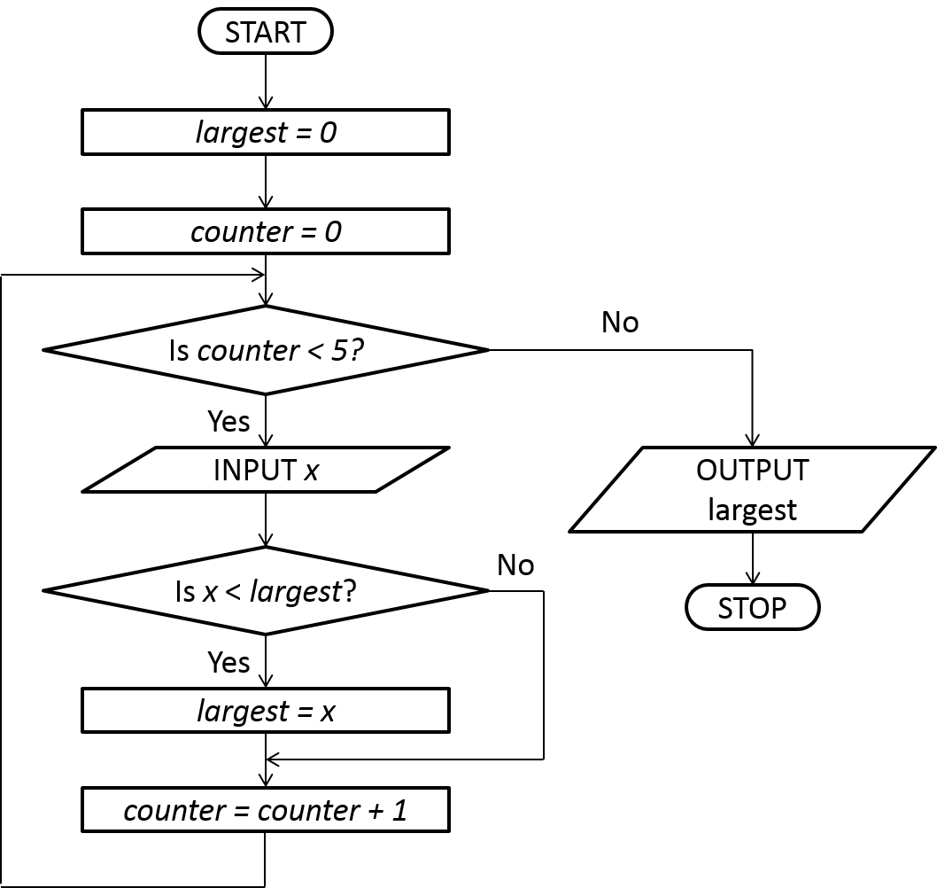

|  |  |  |  |
| --- | --- | --- | --- |
| **counter** | **largest** | **x** | **OUTPUT** |
|  |  |  |  |
|  |  |  |  |
|  |  |  |  |
|  |  |  |  |
|  |  |  |  |
|  |  |  |  |
|  |  |  |  |
|  |  |  |  |
|  |  |  |  |
|  |  |  |  |
|  |  |  |  |
|  |  |  |  |
|  |  |  |  |

Corrected flowchart

|  |
| --- |
|  |

4. Amend the flowchart in question 3 to present an algorithm which is supposed to take in five positive integers and return the smallest integer among the five. You may assume that the largest possible value for all of the integers is 100.